CLIL Back2Basics with Rosie Tanner

2023
More  information?  info@rosietanner.com www.rosietanner.com  06-28745670 | - A course for ‘new’ CLIL teachers

A five-day basic methodology course February – May 2023 for teachers who want to learn (more) about CLIL.
Topics
- What is CLIL? How CLIL am I already?
- Activating in CLIL
- Guiding understanding with text and visual materials
- Encouraging output: getting students to speak and write
- Learning vocabulary

Dates 2023

1. Monday 13 February

2. Tuesday 7 March

3. Thursday 30 March

4. Wednesday 19 April

5. Tuesday 16 May

Times

10:00-16:00 (coffee from 09:30)

Costs €850

Participants

Teachers who want to learn about CLIL but have never
got around to attending a course, have just started teaching in TTO
or are going to teach in TTO. Minimum 12, maximum 16

participants.
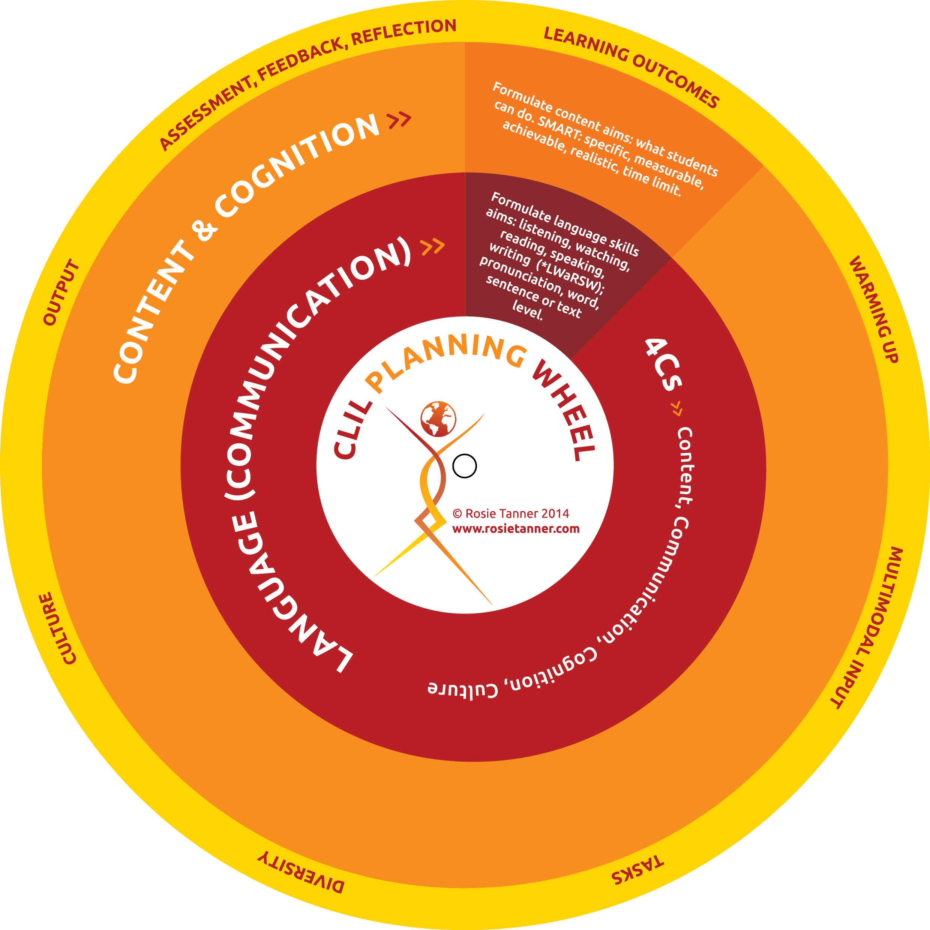

Venue to be announced

Application form: CLIL Back2Basics 2023
info@rosietanner.com
06 28745670
www.rosietanner.com
I would like to attend the CLIL Back2Basics course 2023. Costs €850.
In order to apply for the course, mail this form, completed, to info@rosietanner.com. An invoice and further information about the course and preparation will be sent to your school a month before the course begins.

First name (for certificate) | Surname(s) (for certificate) | Name I like to be called

Mobile phone number

Subject(s) I teach in English

Email address

Any special diet requests?

Full name of school | School address for invoice

Payment
An invoice will be sent to your school just before the course.

